Tutorial 06
Registration Number:- 2018/ICTS/47
Name:- Dinuka Dulanjana
Project Description
• Login Page
- A user-friendly interface for logging in with a username and password.
- Form validation ensures inputs meet required criteria.
- Successful login redirects users to the Home page.
• Registration Page
- Allows new users to sign up by providing details:
  - Full Name
  - Registration Number
  - Index Number
  - Username
  - Email
  - Password and Confirm Password
- Includes form validation techniques to ensure accurate input.
- Provides navigation back to the login page after registration.
• Home Page
- Welcomes the user by displaying their username at the top of the page.
- Includes a Logout Button for user convenience.
- Displays a list of notes relevant to the logged-in user.
- Provides buttons for navigation:
  - Add Note Button: Redirects to the Add Note screen.
  - View Notes Button: Redirects to the View Note screen.
• Add Note Page
- Allows users to create a new note by entering a title and content.
- Includes a save button to store the note in an array.
• View Note Page
- Displays the full content of a selected note.
- Provides options for managing or editing notes in the future (optional feature).

Technical Implementation
- React Navigation:
  - Used for seamless navigation between screens.
  - Stack Navigator manages the app's page transitions.
- Context API:
  - Centralized state management for user authentication and note data.
- Form Validation:
  - Ensures data accuracy on login and registration screens.
- Data Storage:
  - Uses an in-memory array to store user details and notes.

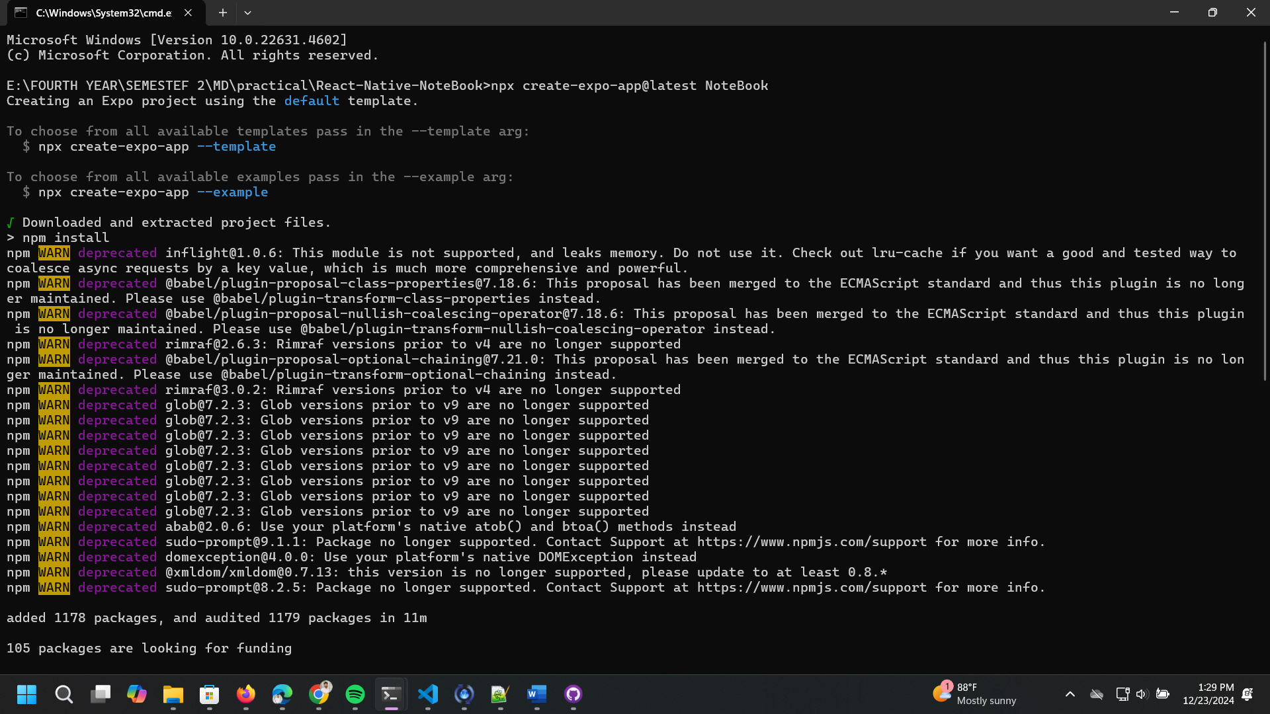

File Structure
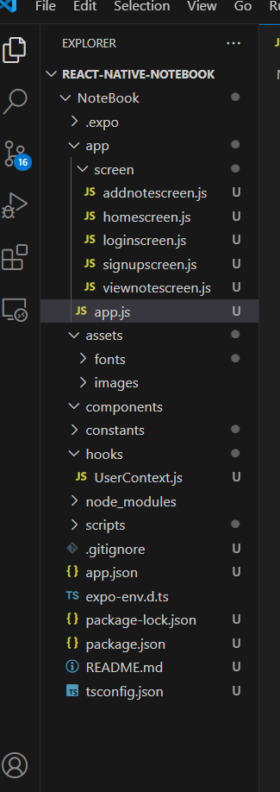

App.js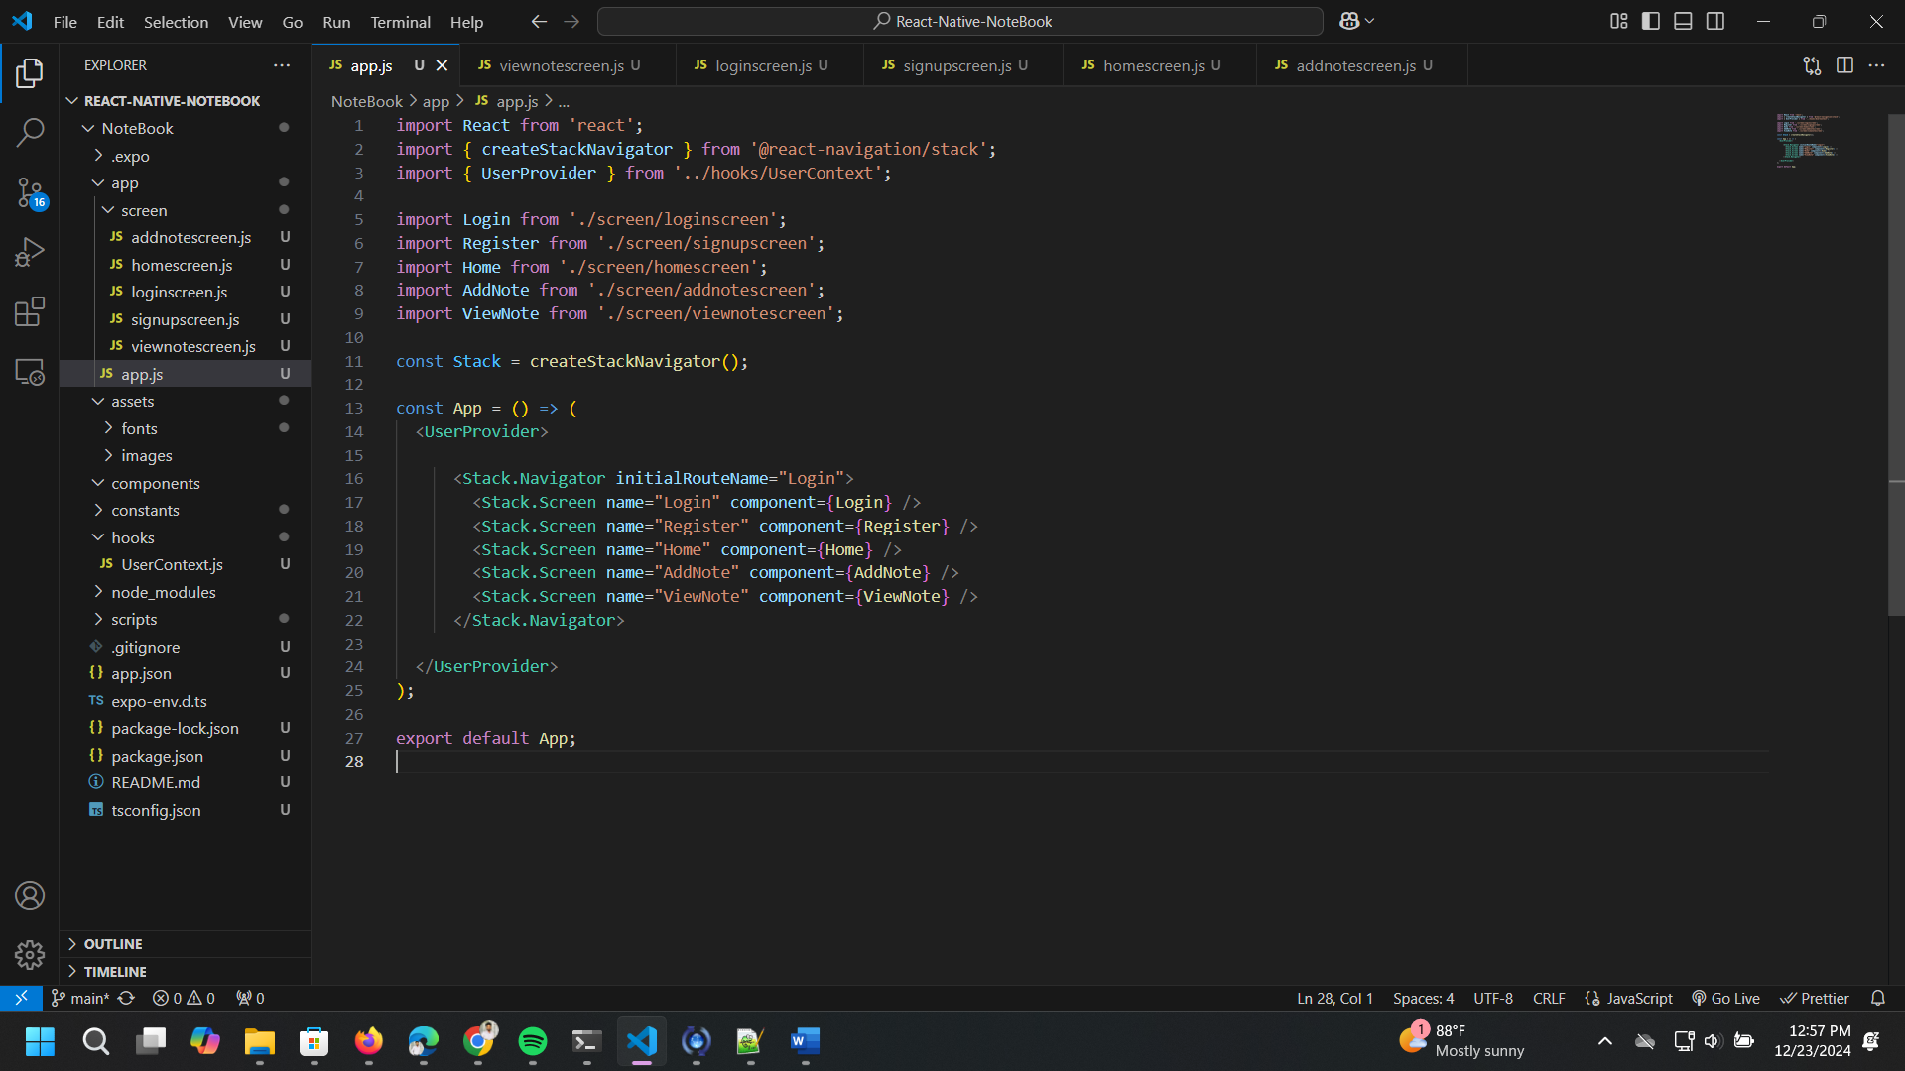

Loginscreen.js
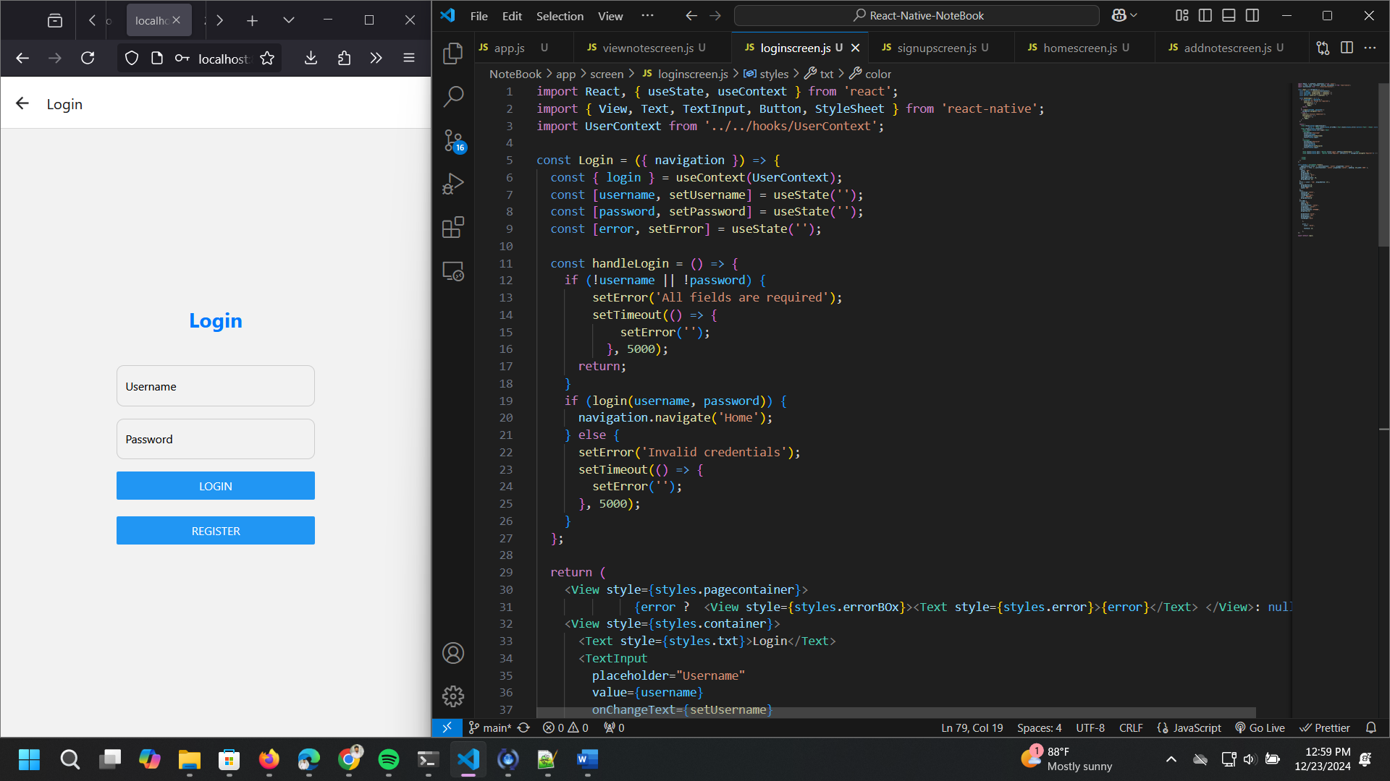

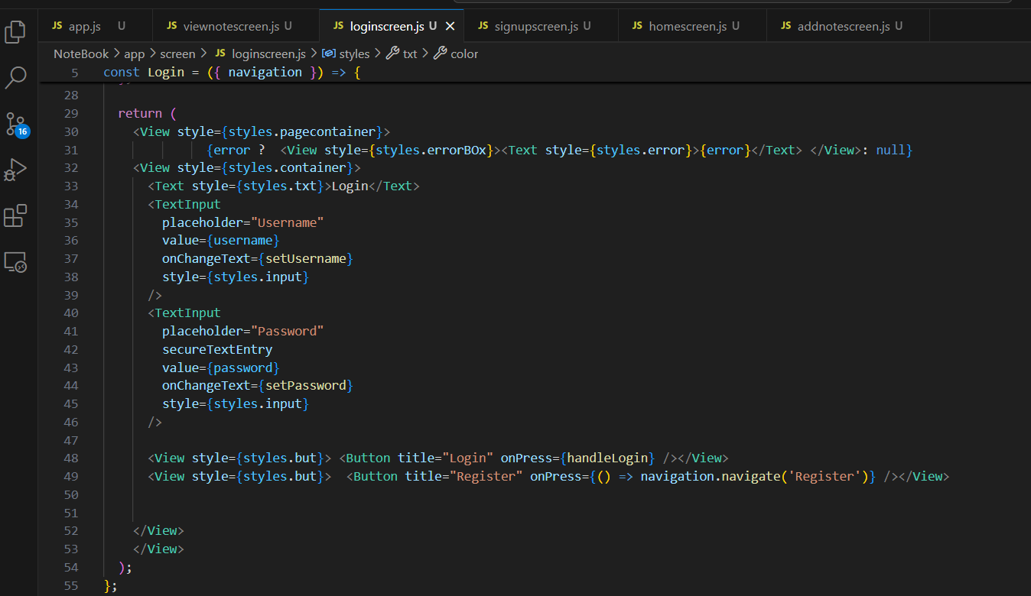
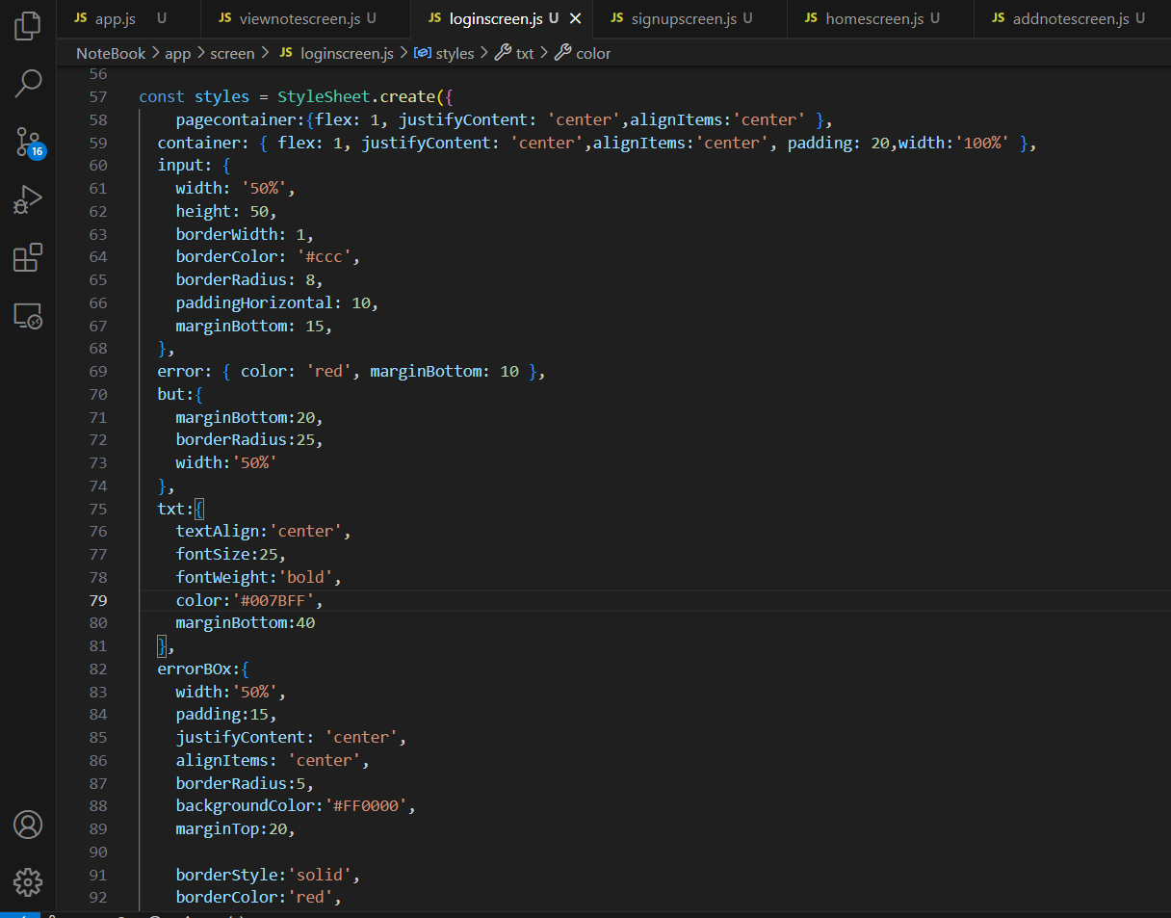

Signupscreen.js
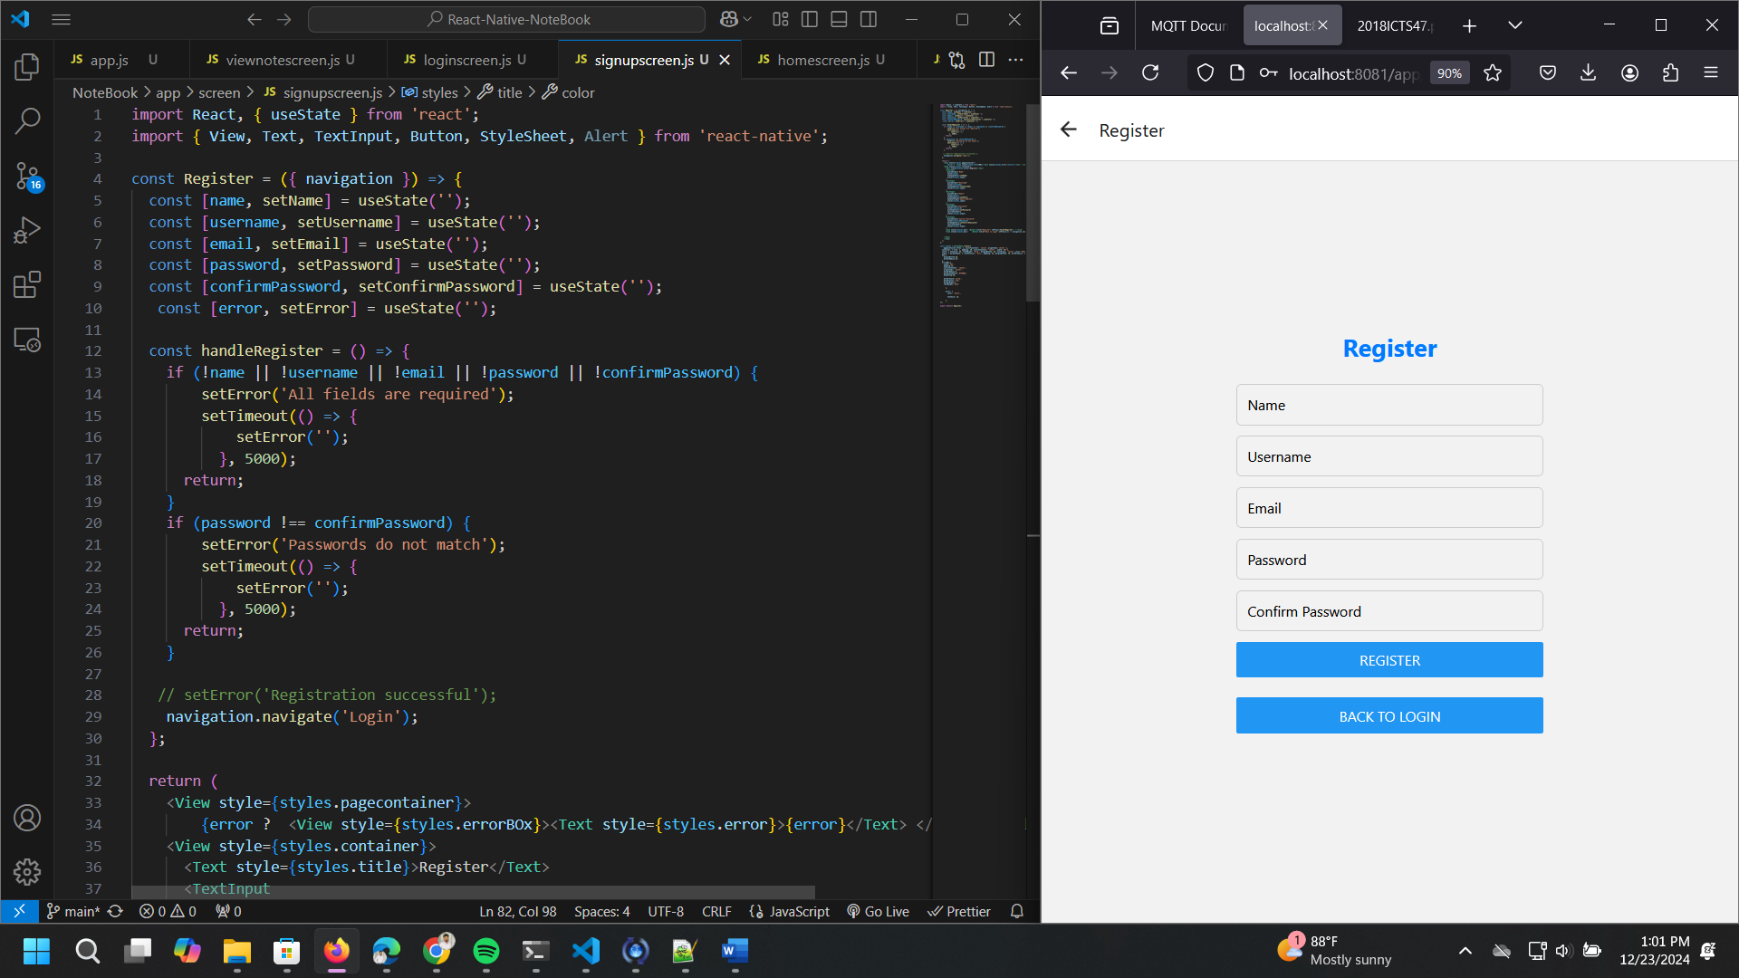
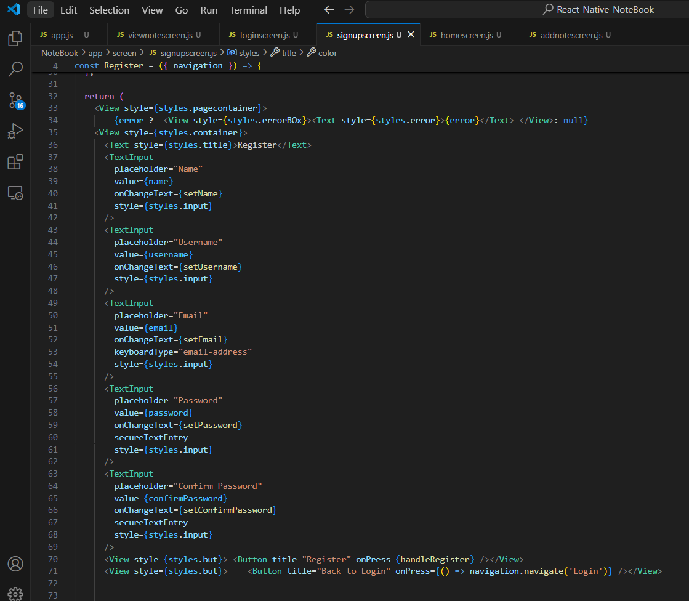
UserContext.js
• State Management:
- user: Stores the logged-in user's data.
- notes: An array of note objects (e.g., { title, content, username }).
• Context Functions:
- loginUser: Sets the logged-in user's information.
- logoutUser: Clears the user's information.
- addNote: Adds a new note to the notes array.
- getUserNotes: Filters and returns notes belonging to the logged-in user.
• Usage:
- Wrap the application with <UserProvider> to make context data available globally.
- Use useContext(UserContext) in components to access or modify user and note data.

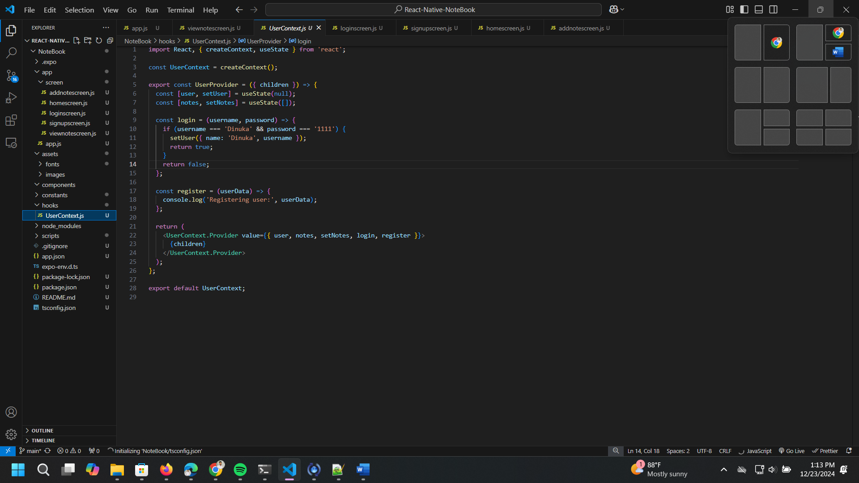

Homescreen.js
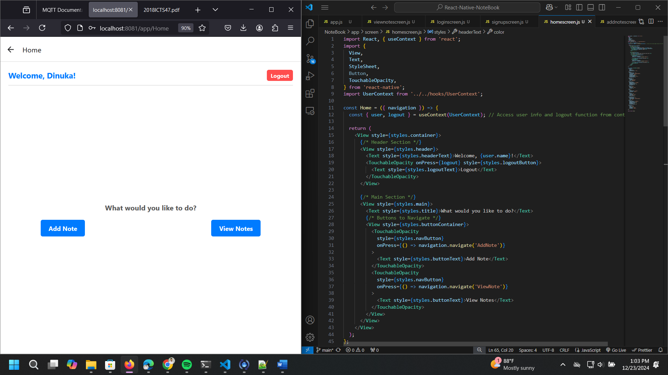

Addnotescreen.js
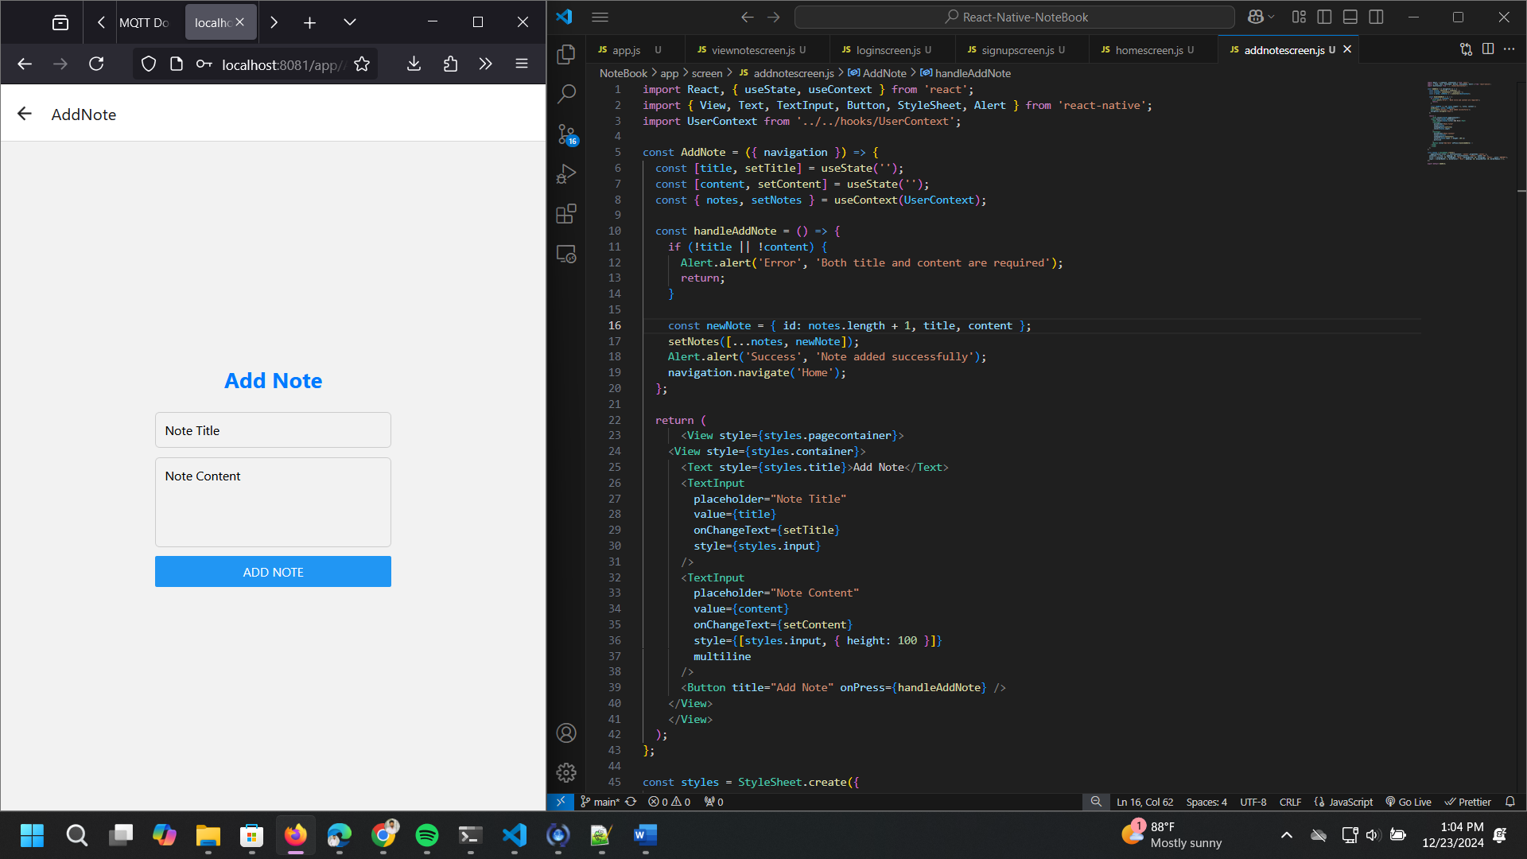

Viewnotscreen.js
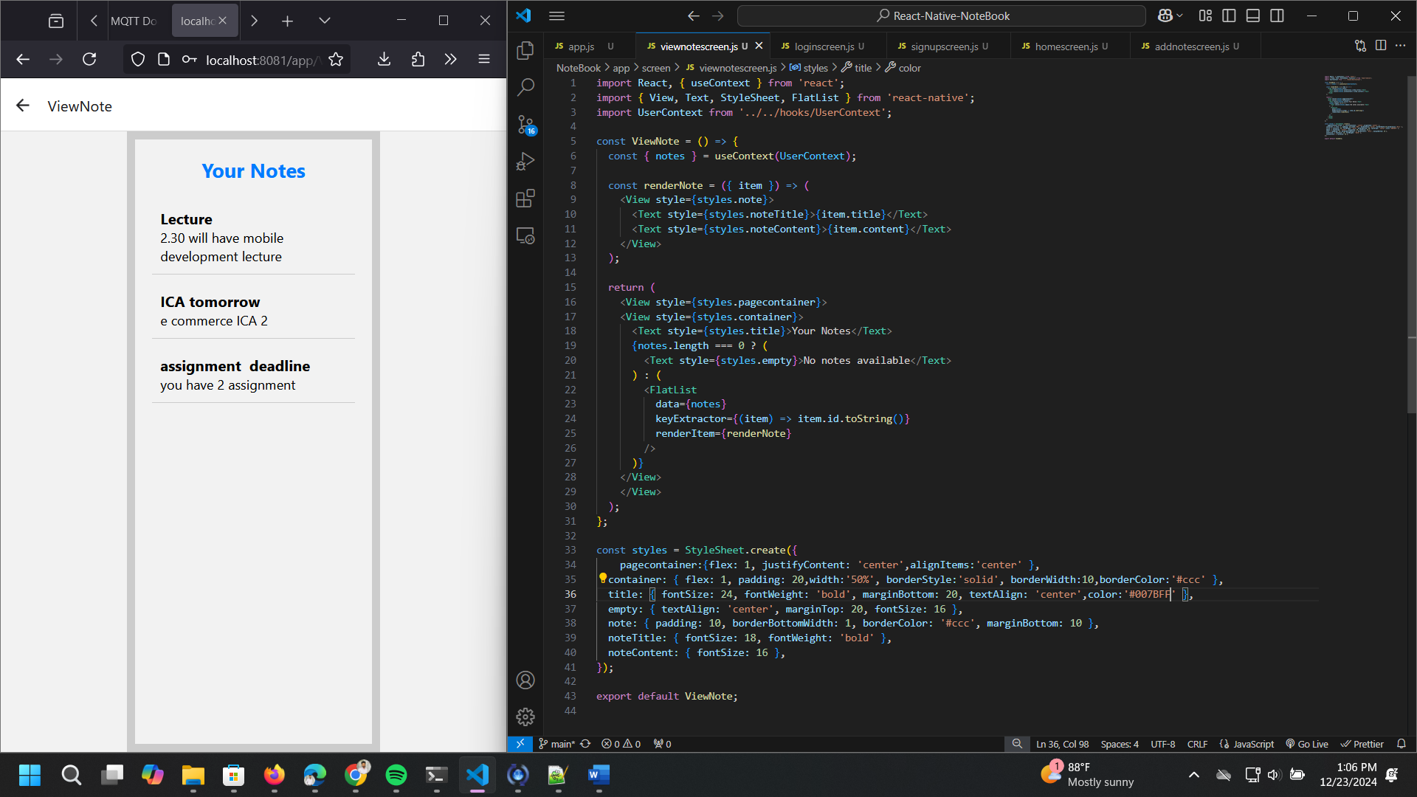

Final outputs
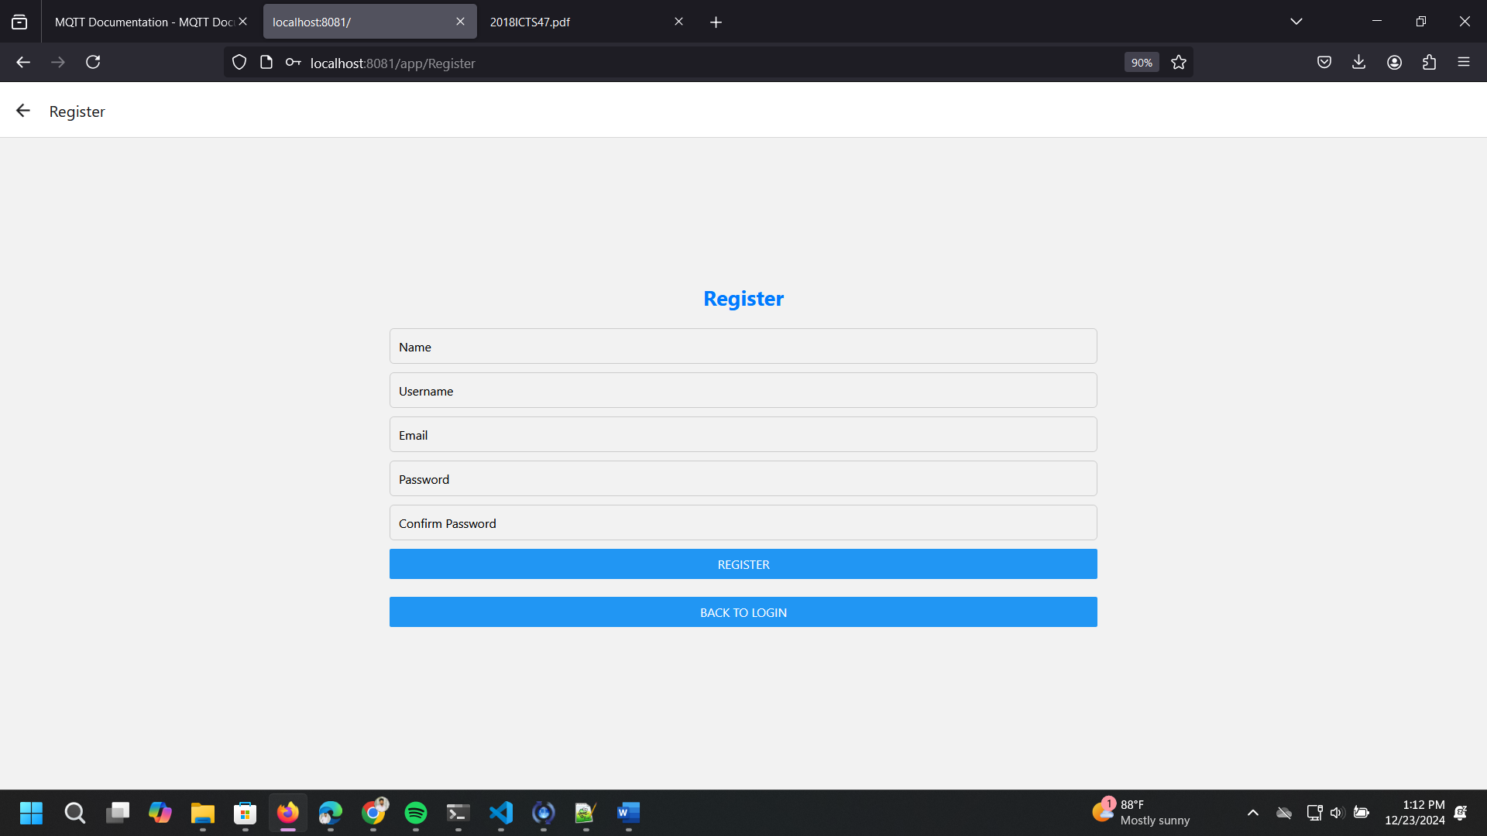
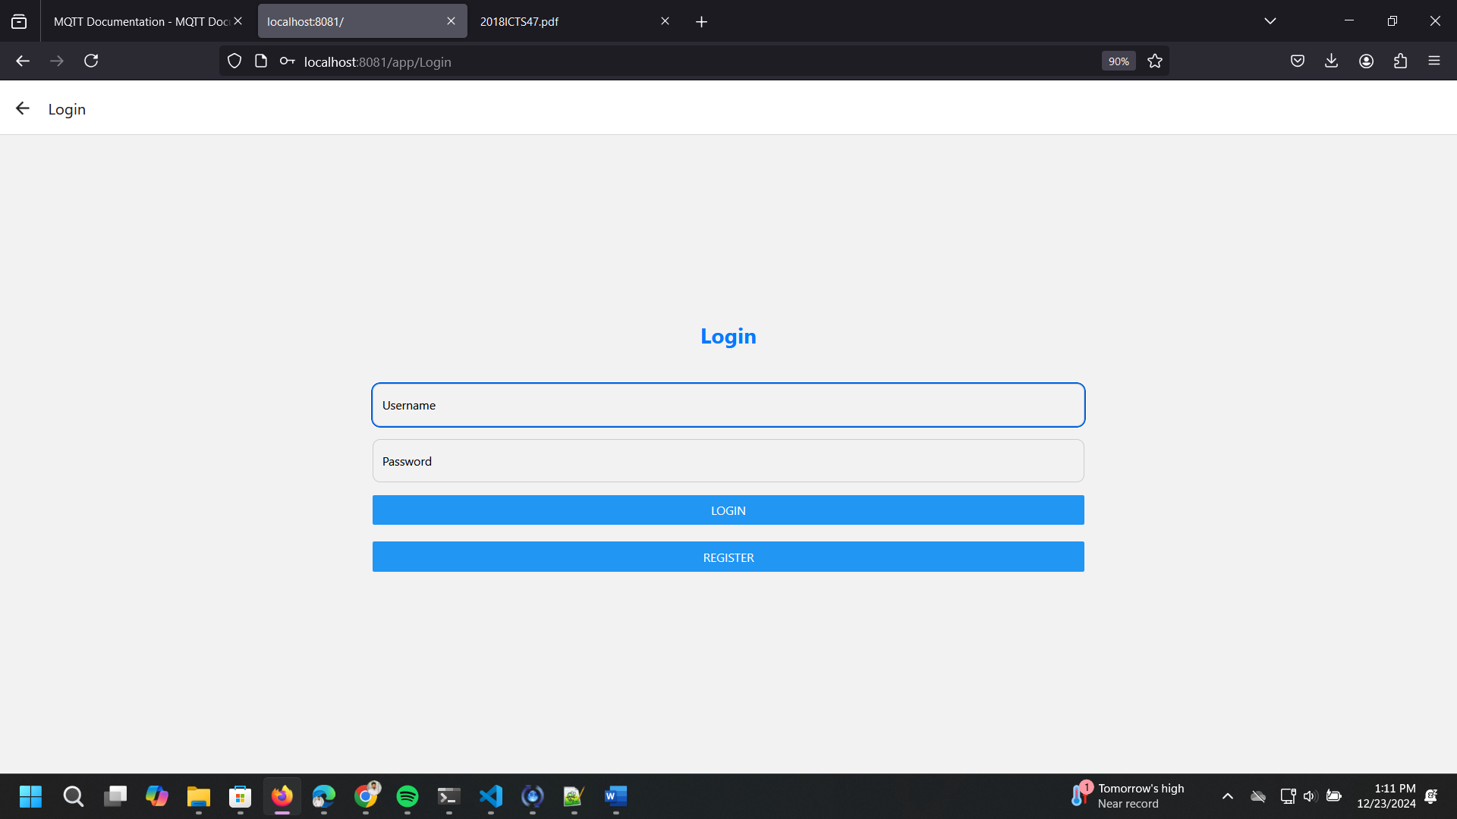
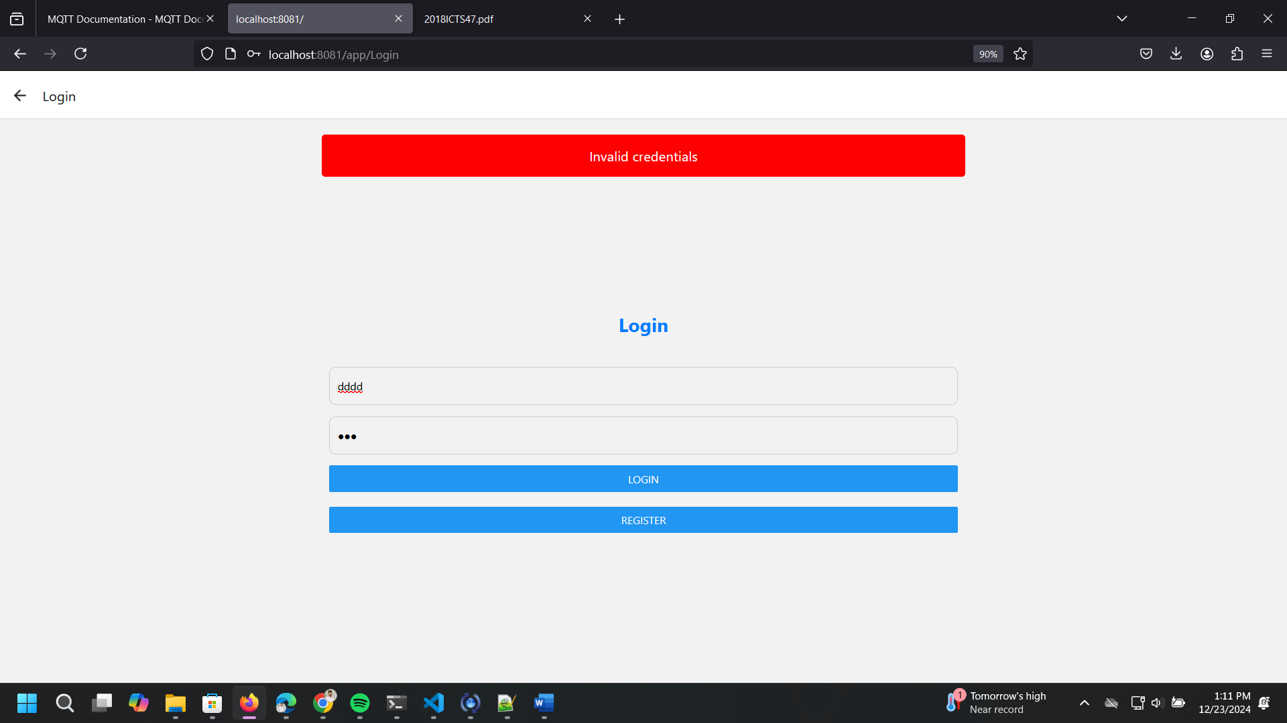
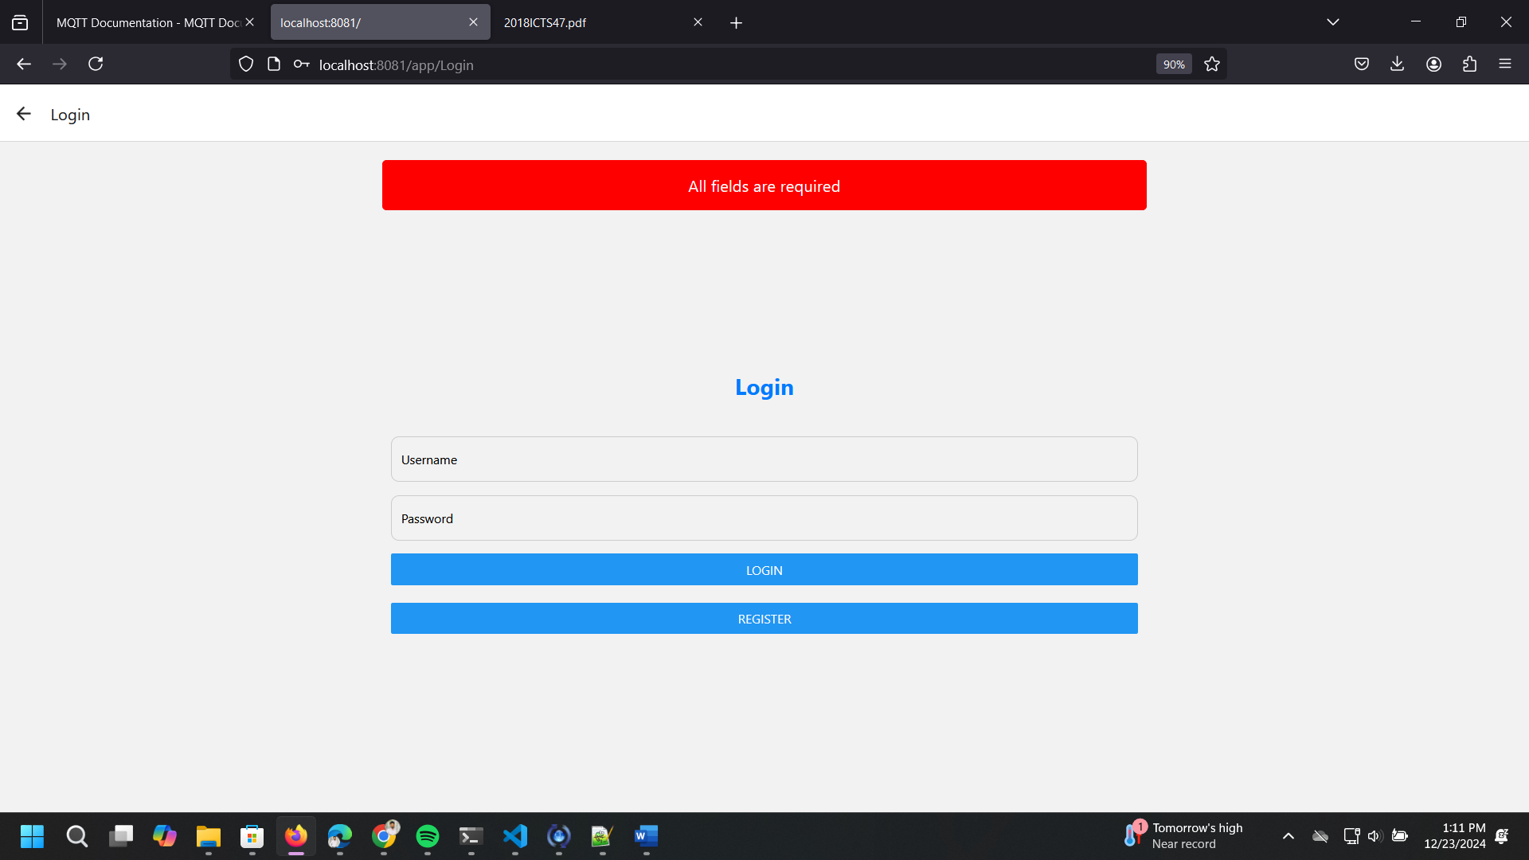
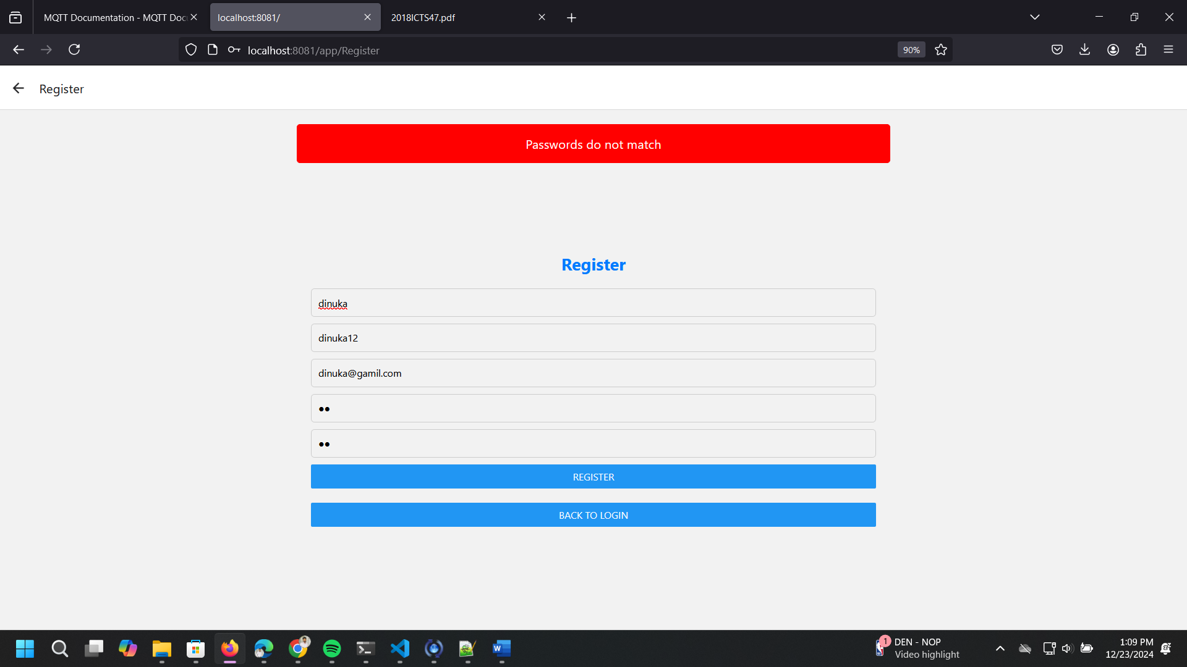
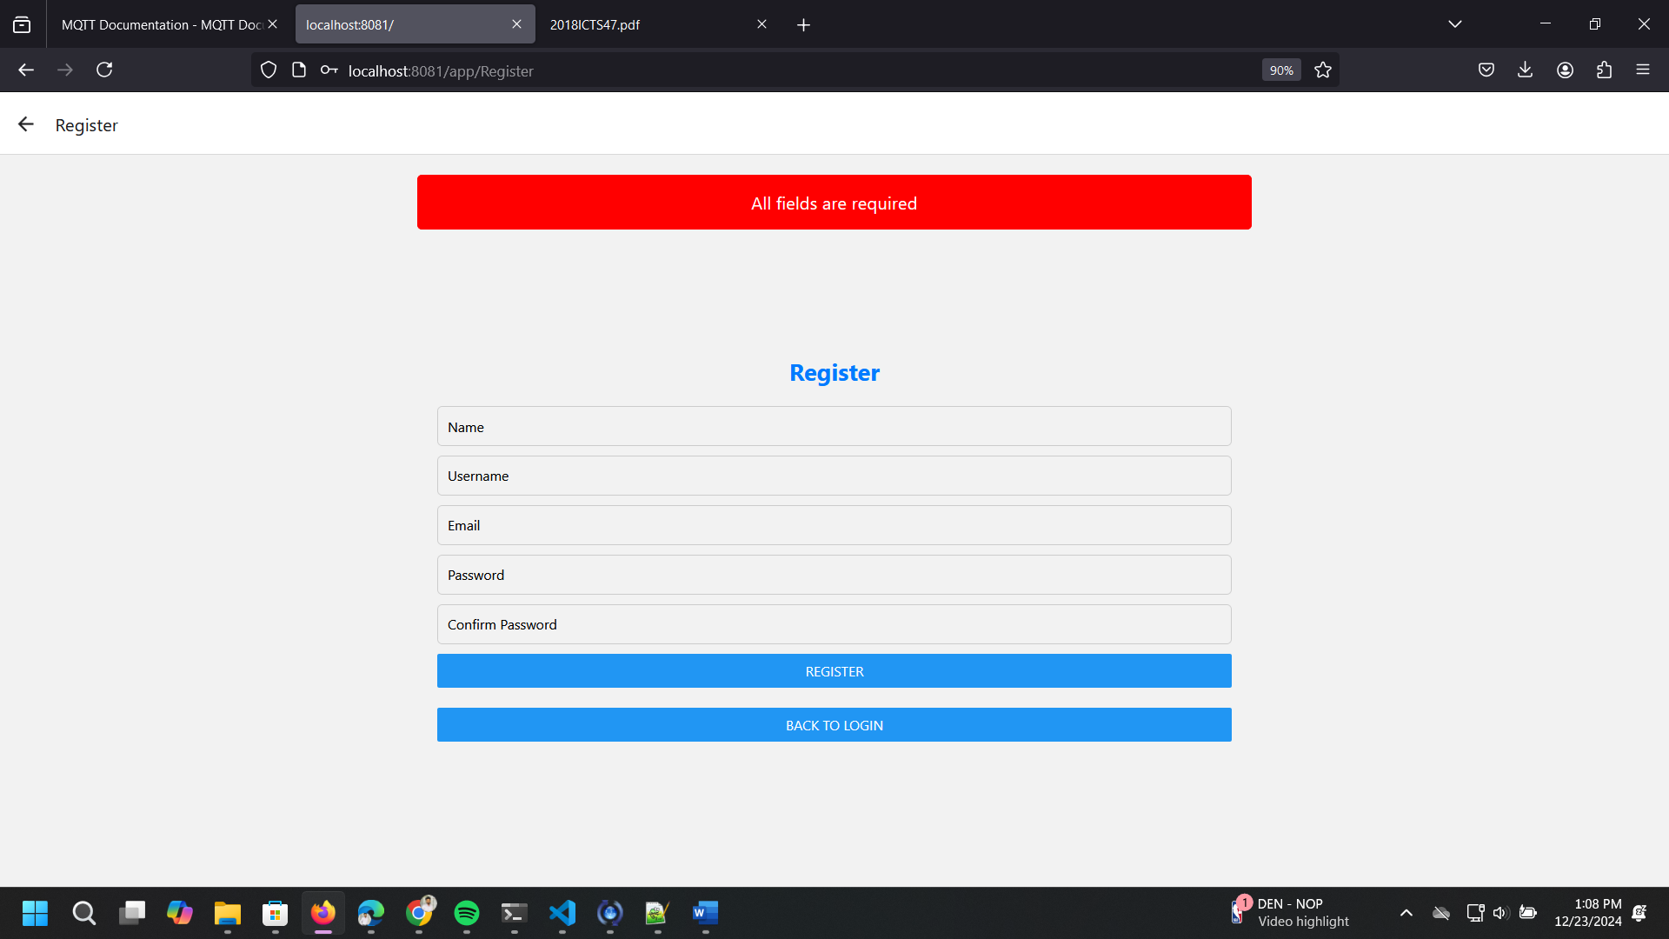
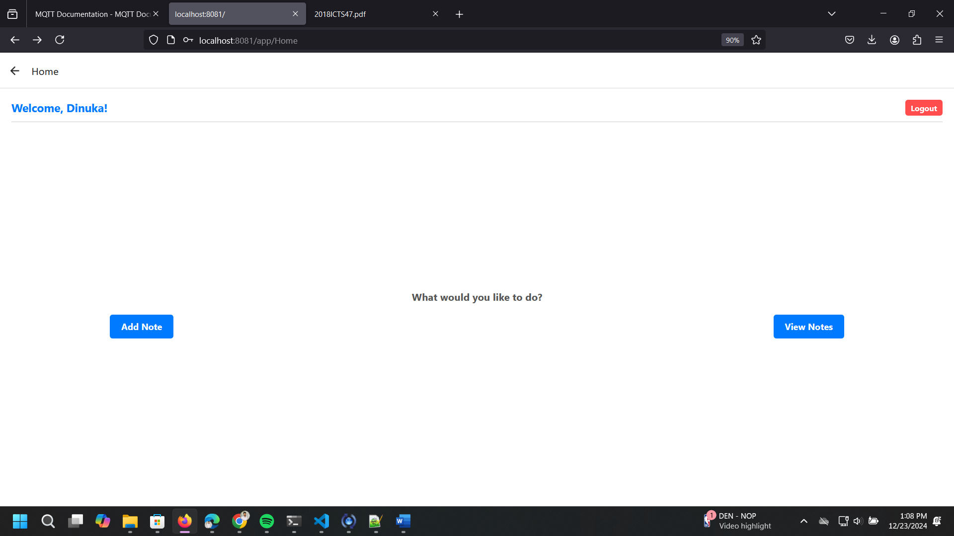
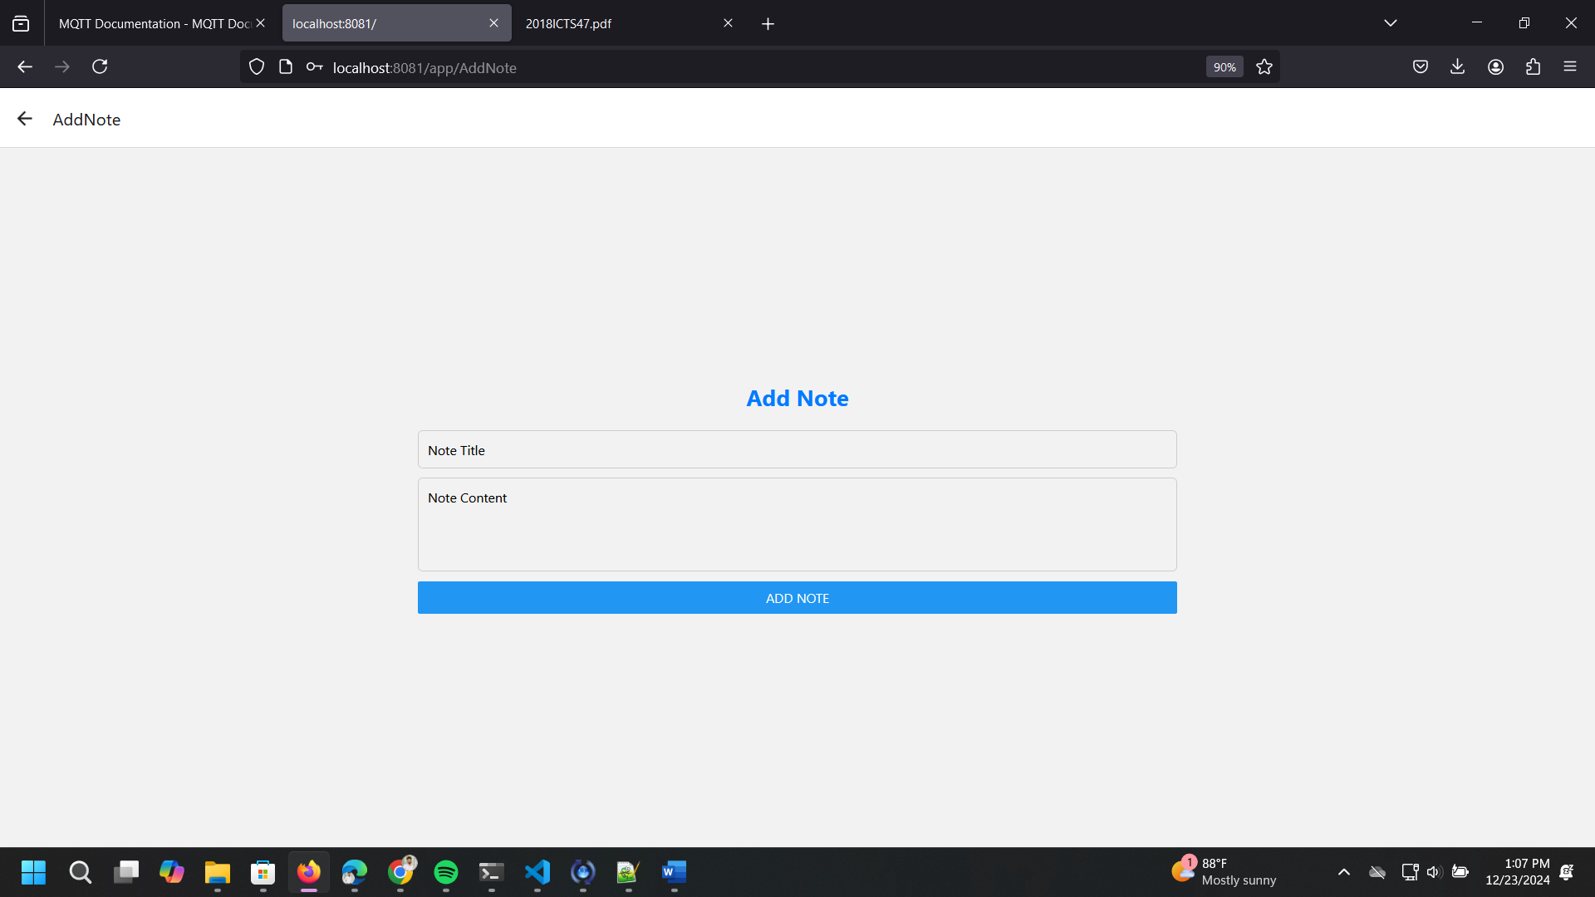
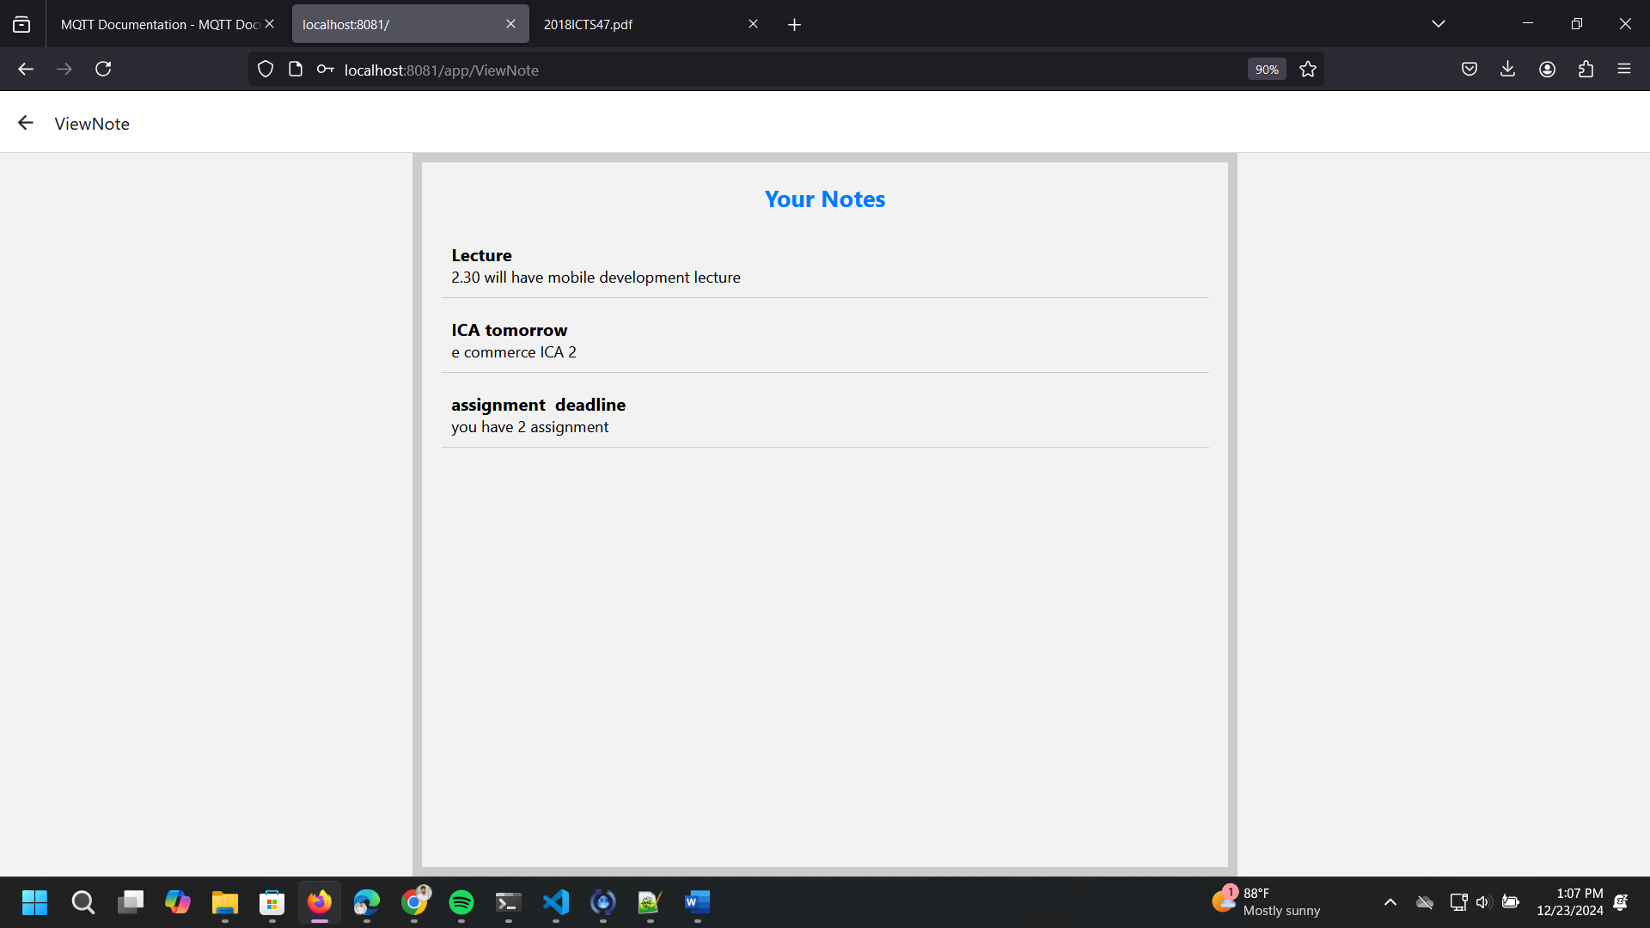

Github link:-
https://github.com/mddranasinghe/React-Native-NoteBook.git

